OBPC (Scientific Section)

TITLE – YOUR RESEARCH (12 pt; BOLD; Таhoma)

First author¹, Next author² (11 pt; normal; Таhoma)
e-mail: (corresponding author) (10 pt; normal; Таhoma)

¹Affilation of author 1 (10 pt; normal; Таhoma)
²Affilation of author 2 (10 pt; normal; Таhoma)

The abstract should be completed in this template. The format should be kept as B5 paper (176 mm × 250 mm), single-sided, with margins of 20 mm. The abstract must be no longer than one page including text, figures, tables, references etc. The font should be Tahoma (10-point), justified with single spacing.

Figure(s) and Table(s) can be included. They should be legible and can be in color.

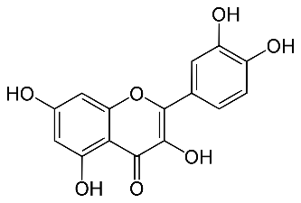

Figure 1. Chemical structure of quercetin.

Keywords: PLA, piezoelectric effect, fibers. (10 pt; normal; Таhoma)

References: (10 pt; normal; Tahoma)
References should be given as superimposed numbers,^{1,2} in line with the text and listed after the body text (10-point), using the style for the references given in the Macedonian Journal of Chemistry and Chemical Engineering.

Keep the Word document (*.docx) format when saving your file for electronic submission.
All abstracts should be submitted online at the following link.

