TITLE
Firs Author¹, Next Author²
e-mail: corresponding author
¹⁻ Affiliation of author 1
²⁻ Affiliation of author 2

Abstract: should be a maximum of 250 words. Paragraph: Before 0, After 6, Single. Font: Segoe UI size: 9.

Keywords (up to 5 words):

INTRODUCTION

Normal text. Paragraph: Before 0, After 6, Single. Font: Segoe UI size: 10. References within the text should be cited in the following form: [1], [2-5], [1, 6-8], [8,9], etc.

EXPERIMENTAL

Normal text. Paragraph: Before 0, After 6, Single. Font: Segoe UI size: 10.

Table 1 Title of Table
Sample | Parameter 1 | Parameter 2 | Parameter 3
1 | Value | Value | Value
2 | Value | Value | Value
3 | Value | Value | Value
4 | Value | Value | Value

RESULTS AND DISCUSSIONS

Normal text. Paragraph: Before 0, After 6, Single. Font: Segoe UI size: 10. The paper should be between 6 and 10 pages.

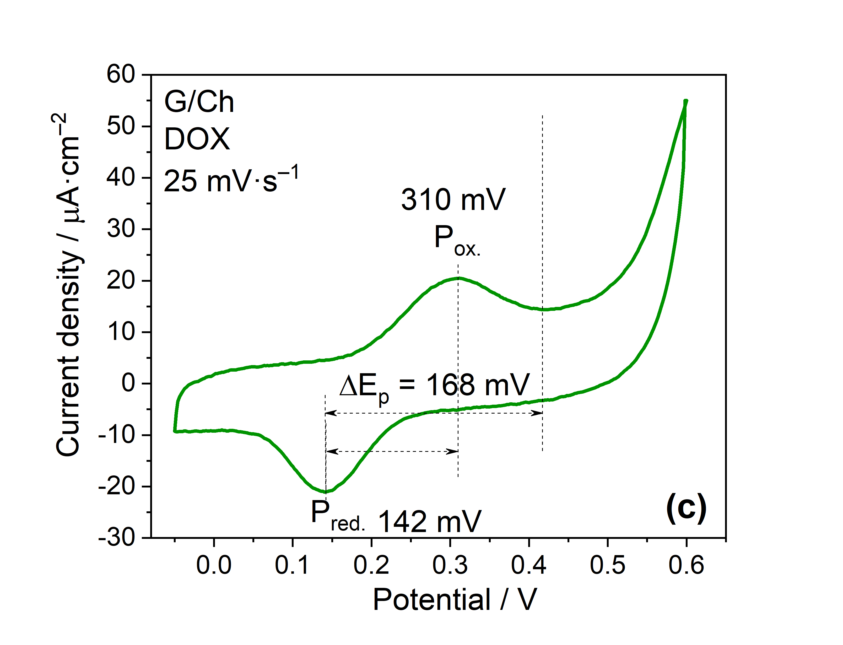

Figure 1 Title of Figure

Normal text. Paragraph: Before 0, After 6, Single. Font: Segoe UI size: 10.

CONCLUSIONS

Normal text. Paragraph: Before 0, After 6, Single. Font: Segoe UI size: 10.

Acknowledgements: Paragraph: Before 0, After 6, Single. Font: Segoe UI size: 9.

REFERENCES
- Journals: [1] A.B. Surname1, C.D. Surname2, Article title, Full Journal Title Vol (Year) first‐last page number https://dx.doi.org/doi.
- Books: [2] A.B. Surname1, C.D. Surname2, Name of Book, Publisher, City, Country, Year, p. 100 https://dx.doi.org/doi.
- Compilations: [3] A.B. Surname1, C.D. Surname2, Name of Chapter, in Name of Compilation, A.B. Editor1, C.D. Editor2, Ed(s)., Publisher, City, Country, Year, p. 100 https://dx.doi.org/doi.
- Proceedings: [4] A.B. Surname1, C.D. Surname2, Name of the Conference or Symposium, Title of the Proceeding, Place of the Conference, Country, Year, p. 100 (or abstract No.).
- Websites: [5] Title of the website, URL in full (date accessed).
- Patents: [6] A.B. Inventor1, C.D. Inventor2, (Holder), Country Code and patent number (registration year).
- Standards: [7] EN ISO 250: Name of the Standard (Year).

